 | SABALE GAYATRI SUDHAKAR  Zeal College of Engineering and Research, Narhe, Pune - 411041  Mobile: +91-9834271573 | Email Id: sablegayaytri3@gmail.com  Address: Flat No-305, Shivaji Park, Narhe-Pune, Near Abhinav College  Pune - 411051  LinkedIn: https://www.linkedin.com/in/gayatri-sable-02a124313 | 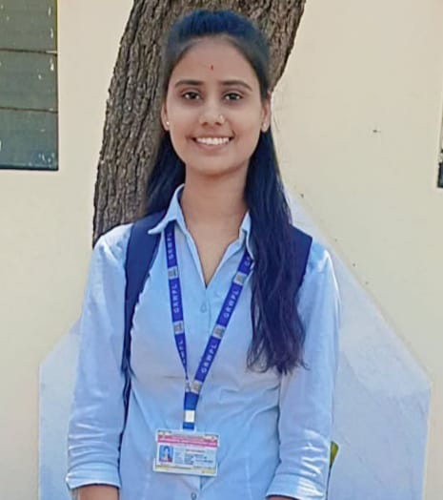

Career Objective
Motivated Diploma Computer Engineer seeking an opportunity to contribute in a competitive corporate environment. Committed to learning, growth, and delivering quality work. Currently pursuing a Degree in Computer Engineering to enhance technical skills and career advancement.
Academic Qualifications
B.Tech in Computer Engineering (Pursuing)
Zeal College of Engineering and Research, Narhe, Pune | 2025-2028 |
Diploma in Computer Engineering
Government Residential Women’s Polytchnic,Latur | 2022-2025 | Cumulative GPA: 90.86%
SSC in Science
Jaykisan Madhyamik Vidhyalay Apegaon | 2021-2022 | Percentage: 96.60%

Technical Skills
- Programming Languages: C, C++, Python, Java
- Web Technologies: HTML, CSS, JavaScript (basic)
- Databases: MySQL, SQLite
- Software Proficiency: MS Office (MS Word, MS Excel, MS PPT)
- Operating Systems: Windows, Linux (basic commands)
- Other Tools: Jupyter Notebook, Eclipse, Visual Studio, Android Studio

Projects

1.Student Feedback System: Developed a secure, multi-role platform to enable anonymous, structured student evaluations of courses and instructors.
​Implemented automated data analytics and role-based reporting to provide administrators and faculty with data-driven insights, improving feedback collection efficiency.

2.Civic Issue Reporting System:
Developed a user-friendly web platform that allows citizens to report daily civic issues and helps authorities track and resolve them efficiently.
Internships
IoT Technology Intern – Synergy Infotech
| June - July 2024
Gained hands-on experience in designing and developing IoT devices, integrating sensors, collecting and visualizing real-time data, and working with platforms like Arduino, Raspberry Pi, and MQTT
.
Achievements
- Publishing a paper or article in a technical magazine or journal.

Extra-Curricular Activiti
Completed online certifications (e.g., Coursera, Infosys springboard, NPTEL) outside curriculum.

Hobbies | Reading | Dancing | Listening Music | Learning New Programming Languages

